Project detailed design
מגישים: יעל אברהם 206656589, עדן פבריקנט
Algorithm
We are developing a clinical prediction system whose goal is to return a numeric estimate of birth weight (in grams) based on maternal/pregnancy information and clinical measurements .
Input: Maternal and pregnancy-related attributes + measurement features (numeric and categorical). Missing values may exist. (we guess)
- Output: prediction (estimated birth weight).
- System constraints:
  - Low-latency inference suitable for hospital workstations and tablets.
  - Robustness to incomplete/noisy real-world data.

Candidate Models :
To justify the final choice, we evaluate several candidates:
Baseline
Linear Regression:
Pros: fast, easy to interpret.
Cons: may underperform when relationships are non-linear or when feature interactions are important.

Simple / Interpretable Models (Linear & Robust Regression Family)
Ridge Regression (L2-regularized linear regression)
Pros: Handles multicollinearity well, reduces overfitting, stable and fast to train/infer.
Cons: Still assumes mostly linear relationships; does not perform feature selection (coefficients shrink but rarely become zero).
Lasso Regression (L1-regularized linear regression)
Pros: Performs automatic feature selection by driving some coefficients to zero; useful when many features may be irrelevant.
Cons: Can be unstable when features are highly correlated. may underperform Ridge/ElasticNet in such cases.
Elastic Net (L1 + L2 regularization)
Pros: Combines the strengths of Ridge and Lasso - better stability than Lasso with correlated features, while still enabling feature selection.
Cons: Adds an extra hyperparameter to tune, which slightly increases tuning complexity.
Huber Regression (robust linear regression)
Pros: More robust to outliers than standard linear regression by using a loss function that is quadratic for small errors and linear for large errors. Often improves reliability in noisy clinical measurements.
Cons: Still linear in nature; needs tuning of the epsilon parameter (controls outlier sensitivity).

Local / Instance-Based Regression
LWLR (Locally Weighted Linear Regression)
Pros: Captures local, non-linear patterns by fitting a small weighted linear model around each query point. Can model complex shapes without explicitly engineering interactions.
Cons: Computationally expensive at prediction time (must compute weights and solve a local fit per request), which can be problematic for real-time APIs. Sensitive to bandwidth/weighting choices and scales poorly with large datasets.

Strong Tabular Models (Tree Ensembles)
Random Forest Regressor:
Pros: handles non-linearities well, relatively robust to noise.
Cons: can be less accurate than boosting for tabular prediction tasks.
Gradient Boosting (XGBoost):
Pros: typically top-performing on tabular data, captures complex interactions, efficient for inference and deployment.

Neural Network Candidate
Neural network can be tested if dataset size justifies it, but it is typically less interpretable and more sensitive to tuning.

Selection Criteria
We compare candidates using both predictive quality and practical deployment considerations:
Criterion | Why it matters for our system
MAE & RMSE | Direct error measurement in grams. RMSE penalizes large errors.
Robustness to missing values | Clinical datasets are often incomplete.
Inference latency | Must respond quickly in a real-time API setting.
Deployability & maintainability | Easy integration into FastAPI, reproducible versions, and reliable updates.

Evaluation Methodology
To avoid inflated performance estimates, we follow a clear evaluation protocol:
Data splitting: We use a Train/Validation/Test split or Cross-Validation. (depends on the size of the data that we get).
Metrics:
  - MAE (average absolute error in grams)
  - RMSE (penalizes large errors)
  - R² (overall goodness-of-fit indicator)
- Hyperparameter tuning:
Grid search / random search on Validation or CV. For boosting models, we may use early stopping (when applicable).
- Leakage prevention:
We exclude any features that could be available only after birth or that indirectly encode the target.
- robustness checks:
We evaluate performance across subgroups or ranges (e.g., early vs late gestational weeks) to ensure stability and reduce blind spots.

Explainability Plan
The system will return:
- Prediction (grams)
- Top contributing features

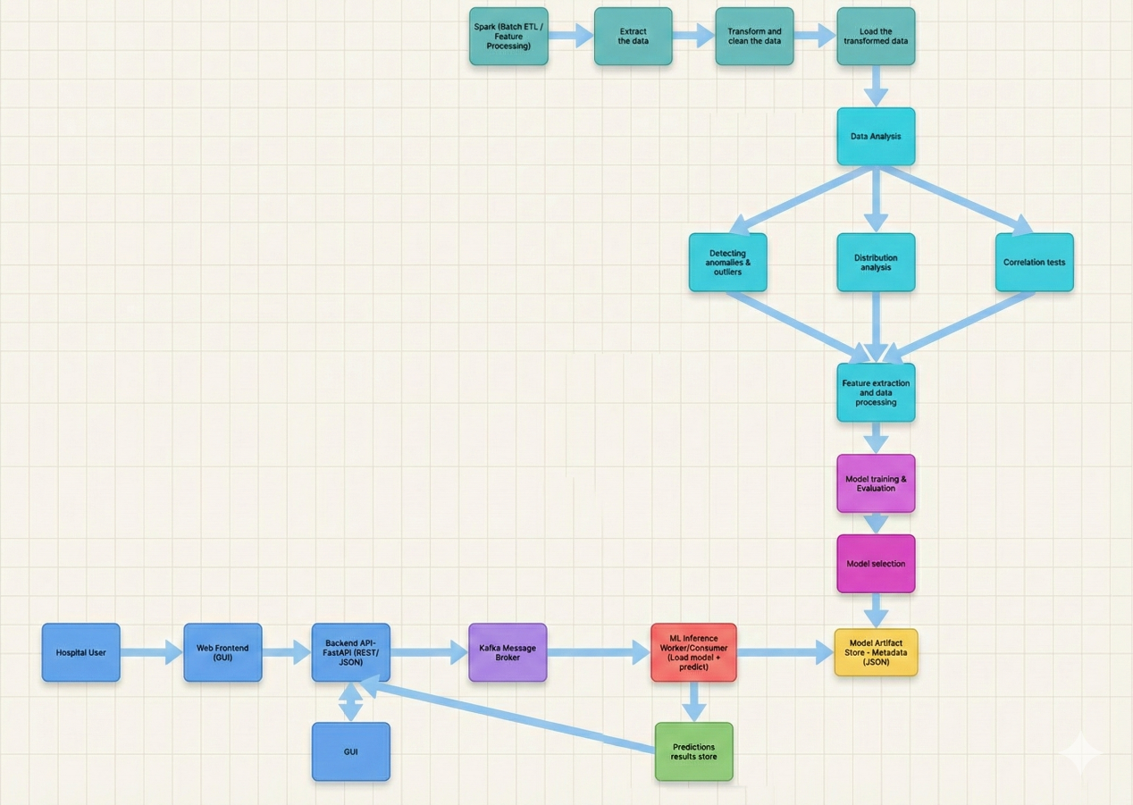
Architecture Diagram
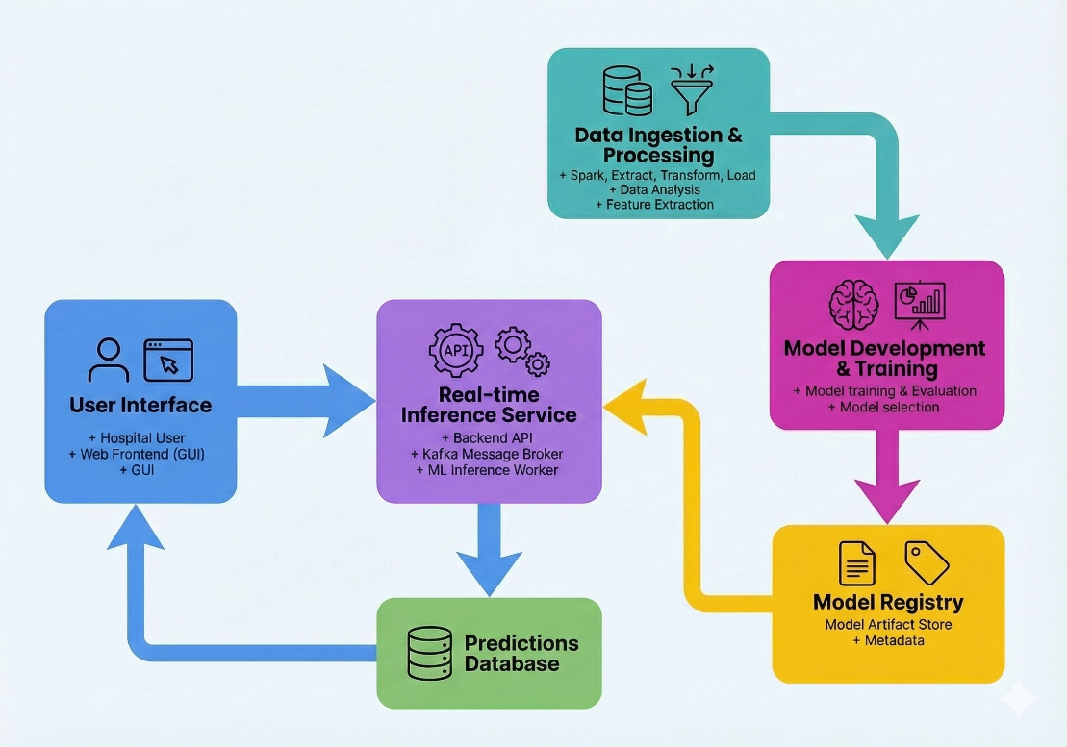
API Specification
Protocol: HTTPS
Payload format: JSON
Prediction
POST /predict
Purpose: Accept a prediction request from the GUI, validate it, and publish it to Kafka.
Input fields (request body):
- features (object/dictionary): the feature vector coming from the GUI (same fields you use in training)

Backend behavior :
- FastAPI validates the fields and types
- Produces a Kafka message to topic: prediction requests

GET /predictions
Purpose: Poll the result of the prediction request.
Output fields (response):
- If DONE:
  - predicted_value
  - uncertainty (lower/upper bounds)
- If FAILED:
  - failure_reason (short message)

Data Validation Rules
- All numeric features must be valid numbers (no text).
- Feature ranges must be realistic
- Missing values: explicitly state which fields may be missing and how they are handled.
- Reject unknown fields or allow them but ignore them.

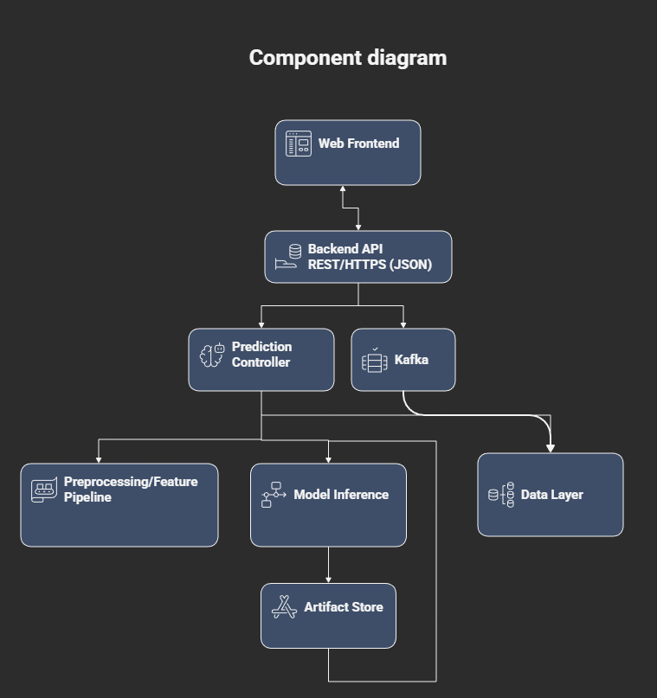
Component diagram

Technology Stack Selection
Frontend: React
Reason: fast UI development, maintainable components, good form handling.
Backend: Python 3.9+ with FastAPI
Reason: strong validation ,high performance, easy ML integration.
ML/DS: scikit-learn, NumPy, Pandas, tensor, matplotlib, plotly
Reason: stable, academic-friendly, reproducible pipelines.
Kafka
Reason: Makes better handling for Big data.

Integration and Communication Protocols
This section is about how components talk to each other.
What to specify:
- Client - API
  - Protocol: HTTPS
  - Style: REST
  - Format: JSON
- API - Artifact Store
  - File read (local path) or object storage API
- Kafka
  - Protocol: Kafka TCP

